Level-6

Final Project

“Package and Delivery”

By

Sumanpreet Singh

Table of Contents

Project Proposal 3

Goals and Objectives 3

Project Scope 3

Project Deliverables 3

Project Specifications 3

Target Audience 4

Project Tasks and Milestones 4

Resource Requirements 5

Project Risks 5

Software Project Report 6

Analysis 6

Requirements Analysis 6

Detail Design 7

Home Page 7

Registration Page 8

Login Page 9

Admin Sender Page 9

Admin Couriers List Page 10

Admin Package Deliveries Page 11

Sender Package Delivery Page 11

New Sender Registration Page 12

Project Testing 13

System Usability Testing 13

Testing 13

User Manual 15

Quick Setup Guide 15

User Setup 15

Admin Setup 15

General Information 15

System Overview 15

System Summary 15

System Configuration 15

User Access Levels 15

# Project Proposal

## Goals and Objectives

The goal of this project is to implement an online web app named “Package and Delivery”. This web app consists of admin and Sender. Admin can add, edit, delete, and check details of the senders. Senders can add new deliveries request, edit, delete, and check details of the package deliveries. Admin can also add new courier, edit, delete and check details for the same. Moreover, admin can edit, delete, and access details of the packages. Admin can register new admins and new senders can sign up for the application for free.

## Project Scope

This is a 20 days project in which I have implemented an online web application named “Package and Delivery”. The scope of this project is to help people to send and receive their packages and couriers easily and effortlessly.

## Project Deliverables

The following table states the deliverables for the project:

|  |  |
| --- | --- |
| **Deliverable** | **Description** |
| Final Report | Introduces the plan and elaborates the specifications and criteria, as well as presents the goal, timeline, code and other important details. |
| Coding | This will be the project's executable code. |
| Documentation | This will demonstrate how the web application can be used. |
| Testing | This will provide the project's test details |

## Project Specifications

* Add, Edit, delete, and access details of the senders.
* Admin can add, edit, delete, and access details of the courier.
* Admin can edit, delete, and access details of the packages.
* Sender can add new delivery requests.
* Sender can edit, delete and access details of the package deliveries.

## Target Audience

* People who want to send and receive their courier and package easily and reliably can be aged from 18 to 100 plus.

## Project Tasks and Milestones

The tasks and milestones of the project are as follows

|  |  |  |  |  |  |  |  |  |  |  |  |  |  |  |  |
| --- | --- | --- | --- | --- | --- | --- | --- | --- | --- | --- | --- | --- | --- | --- | --- |
| **Stages** | **Activities** | **Week1-2** | | | | **Week-2-3** | | | | | **Week-3-4** | | | | |
| Planning | **Technological analysis and brainstorming** |  |  |  |  |  |  |  |  |  |  |  |  |  |  |
| **Initial Meeting** |  |  |  |  |  |  |  |  |  |  |  |  |  |  |
| **Project Proposal** |  |  |  |  |  |  |  |  |  |  |  |  |  |  |
| **Proposal Documentation** |  |  |  |  |  |  |  |  |  |  |  |  |  |  |
| Implementation | **Database Design** |  |  |  |  |  |  |  |  |  |  |  |  |  |  |
| **UI Design** |  |  |  |  |  |  |  |  |  |  |  |  |  |  |
| **Identity Framework Implementation** |  |  |  |  |  |  |  |  |  |  |  |  |  |  |
| **UI Implementation** |  |  |  |  |  |  |  |  |  |  |  |  |  |  |
| **Admin Interface Implementation** |  |  |  |  |  |  |  |  |  |  |  |  |  |  |
| **User interface Implementation** |  |  |  |  |  |  |  |  |  |  |  |  |  |  |
| **Testing** |  |  |  |  |  |  |  |  |  |  |  |  |  |  |
| Closing | **Final Documentation** |  |  |  |  |  |  |  |  |  |  |  |  |  |  |

## Resource Requirements

Following technologies and development method:

* Asp.net MVC Framework
* Identity framework- ASP
* Windows Operating System
* 64-bit processor and 8 GB or more RAM

## Project Risks

The following are the high risks which could affect the execution and progress of the project:

* Project delays can lead to chain delays for other related tasks.
* The plan can be underestimated in size and length.
* For the project with confidential information, exceptional application protection must be given.
* The full required features can prevail over the time available from the developer.

|  | **Low (Yes)** | | | | **RISK** | | | | **(No) High** | | | |
| --- | --- | --- | --- | --- | --- | --- | --- | --- | --- | --- | --- | --- |
| 0 | 1 | 2 | 3 | | 4 | 5 | 6 | | 7 | 8 | 9 |
| **Inherent Risks** |  |  |  |  | |  |  |  | |  |  |  |
| **Project Objectives** |  |  |  |  | |  |  |  | |  |  |  |
| Is it a small project? |  |  |  |  | |  |  |  | |  |  |  |
| Is the plan less important for the company? |  |  |  |  | |  |  |  | |  |  |  |
| Does the plan work in advance? |  |  |  |  | |  |  |  | |  |  |  |
| Is the topic well documented? |  |  |  |  | |  |  |  | |  |  |  |
| **User Organisation** |  |  |  |  | |  |  |  | |  |  |  |
| Does the project maintain current customer procedures? |  |  |  |  | |  |  |  | |  |  |  |
| Is any additional organizational change unlikely during the project? |  |  |  |  | |  |  |  | |  |  |  |
| **Technology** |  |  |  |  | |  |  |  | |  |  |  |
| Will hardware be used? |  |  |  |  | |  |  |  | |  |  |  |
| Is it possible to avoid programming? |  |  |  |  | |  |  |  | |  |  |  |
| Is the project technically advanced? |  |  |  |  | |  |  |  | |  |  |  |
| Does existing data quality work? |  |  |  |  | |  |  |  | |  |  |  |
| **Acquired Risks** |  |  |  |  | |  |  |  | |  |  |  |
| **Scope and Goal** |  |  |  |  | |  |  |  | |  |  |  |
| Is the scope of the project well established and well agreed? |  |  |  |  | |  |  |  | |  |  |  |
| Is the project objective well defined and agreed upon? |  |  |  |  | |  |  |  | |  |  |  |
| **Project Organisation** |  |  |  |  | |  |  |  | |  |  |  |
| Are users engaged in the project? |  |  |  |  | |  |  |  | |  |  |  |
| Are the skills required? |  |  |  |  | |  |  |  | |  |  |  |
| Do all team members have a backup? |  |  |  |  | |  |  |  | |  |  |  |
| Is the project independent from a third party? |  |  |  |  | |  |  |  | |  |  |  |
| Can a small group accomplish design? |  |  |  |  | |  |  |  | |  |  |  |
| **Experience, Training and Support** |  |  |  |  | |  |  |  | |  |  |  |
| Is the technology known to the IT department? |  |  |  |  | |  |  |  | |  |  |  |
| Are users familiar with code? |  |  |  |  | |  |  |  | |  |  |  |
| Is the software provided well? |  |  |  |  | |  |  |  | |  |  |  |

# Software Project Report

## Analysis

### Requirements Analysis

#### Functional

The functional requirements of this project are divided into types. One for Admin, and one for Sender.

|  |  |
| --- | --- |
| **Users** | **Functional Requirements** |
| **Admin** | * Add can add, edit, delete, and access details of senders. * Admin can add new couriers, edit, delete and access details of existing couriers. * Admin can edit, delete, and check details of the packages. |
| **Sender** | * Can add a new delivery request. * Can edit, delete, and access details of the package deliveries. |

#### Non-Functional

|  |  |
| --- | --- |
| **Operational** | * The app should be able to run on all browsers and devices. |
| **Performance** | * Aiming to have a 99% performance uptime. |
| **Security** | * Only Admin have full access to the system. |

## Detail Design

### Home Page

This is the main landing page of the application. This page contains 5 main navigation buttons – Home, Packages, Signup as a Sender, Login and Register delivery admin.

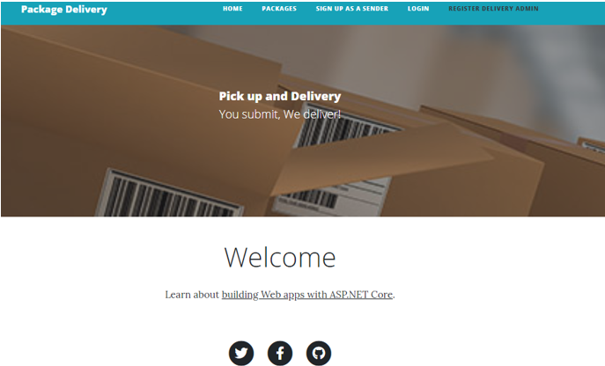

### Registration Page

An Admin can register another admin by using the register page.

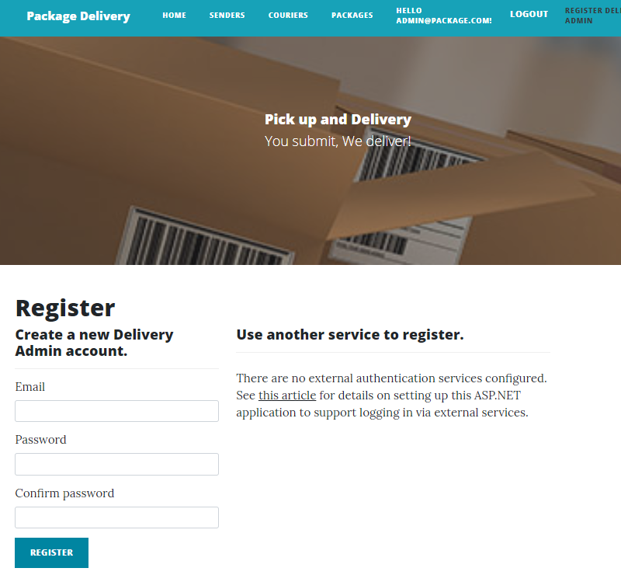

### Login Page

With the help of this page, admin and sender can login to the application by using their credentials.

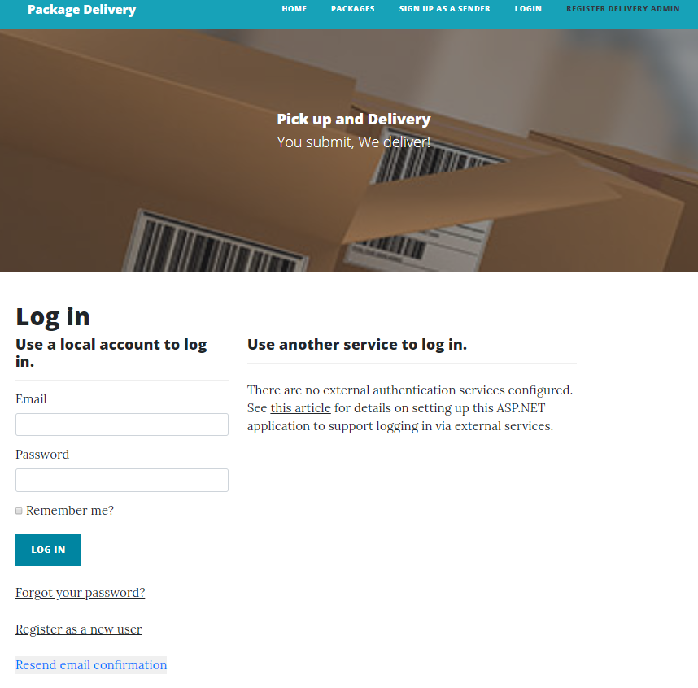

### Admin Sender Page

With the help of this page, admin can add, edit, delete and view the details of the senders.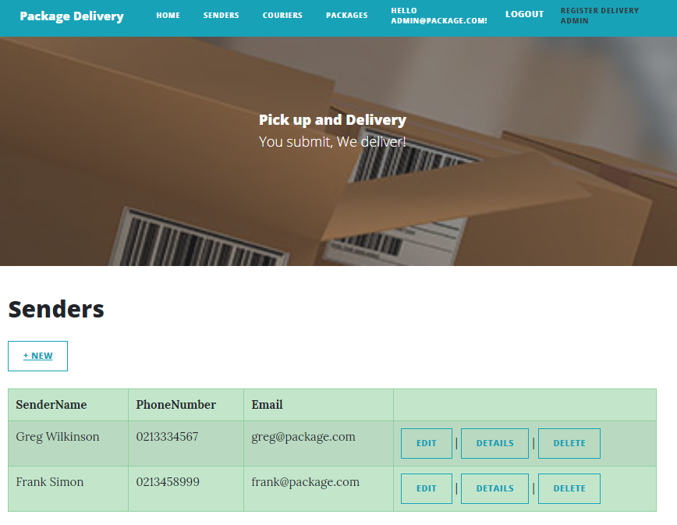

### Admin Couriers List Page

With the help of this page, admin can add, edit, delete and view details of the couriers.

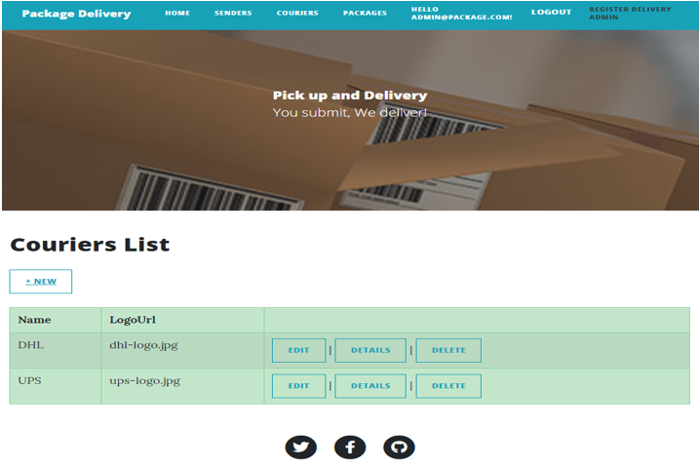

### Admin Package Deliveries Page

An admin can edit, delete and see the details of the Package Deliveries.

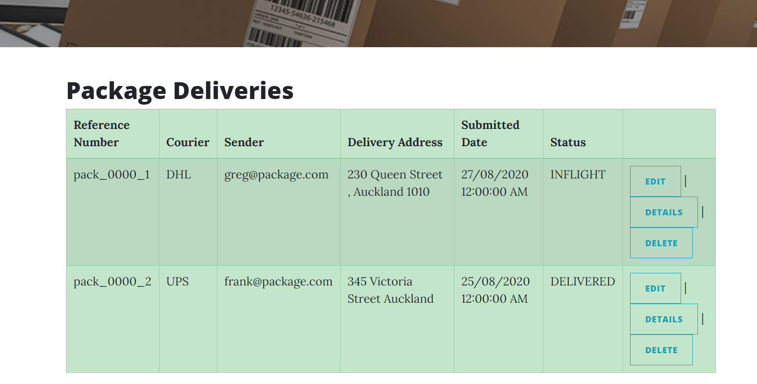

### Sender Package Delivery Page

With the help of this page, registered senders can add new delivery requests, edit, delete and access details of the current package deliveries.

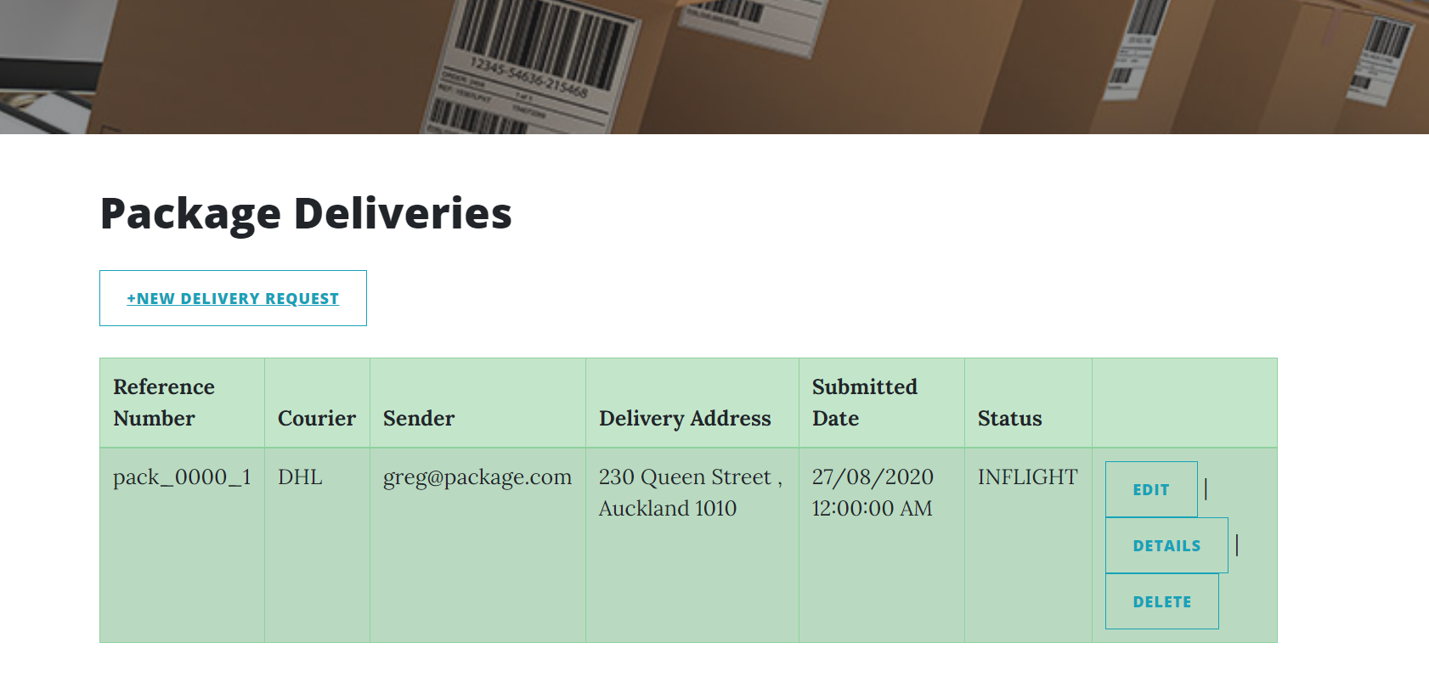

### New Sender Registration Page

With the help of this page, new sender can signup.

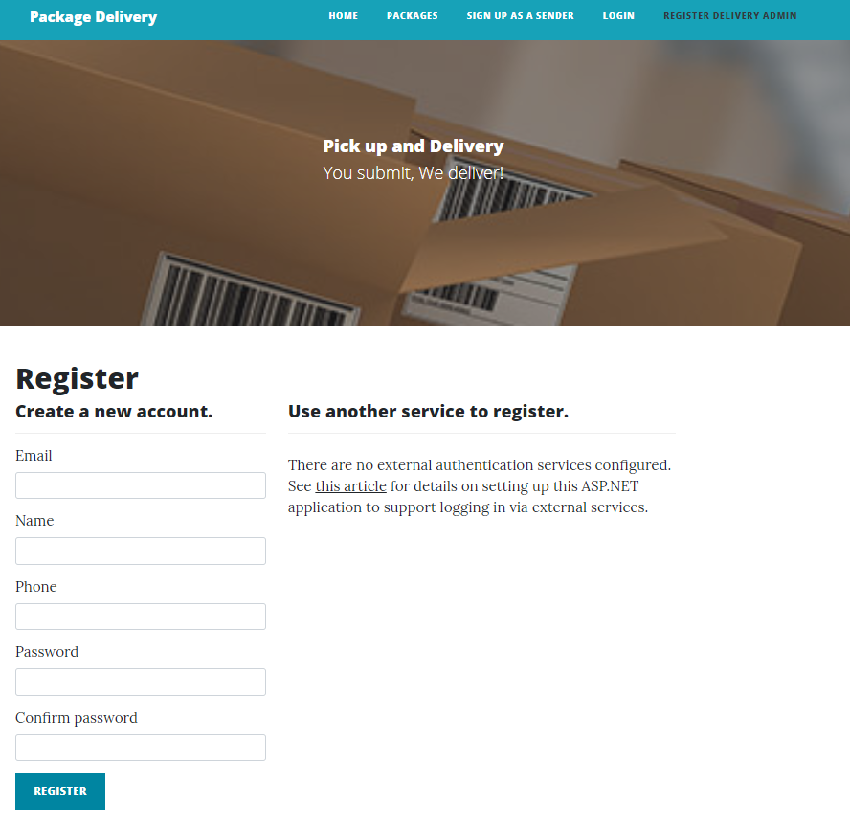

Create Package Sender View

When the senders will click on the new delivery request, this page will appear and send can create a package as per their choice.

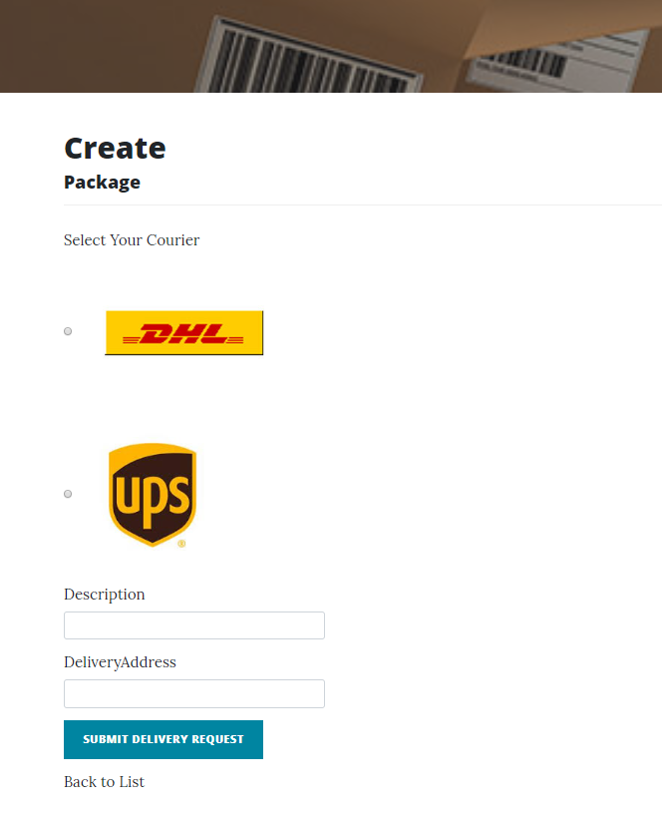

# Project Testing

## System Usability Testing

### Testing

|  |  |  |  |  |  |
| --- | --- | --- | --- | --- | --- |
| **Tester – 1** | | **Scale** | | | |
| **No.** | **Question** | **Strongly Agree** | **Agree** | **Neutral** | **Disagree** |
| 1 | I think that I would like to use this application more frequently |  |  |  |  |
| 2 | I found the system complicated |  |  |  |  |
| 3 | Is system easy to use? |  |  |  |  |
| 4 | Do you think you need the support of a technical person to use this system? |  |  |  |  |
| 5 | All functions of the system were well integrated |  |  |  |  |
| 6 | Did you find any inconsistencies in this system |  |  |  |  |
| 7 | I think most people would learn to use this system very quickly |  |  |  |  |
| 8 | I found the system very challenging to use |  |  |  |  |
| 9 | I felt very confident using the system |  |  |  |  |
| 10 | I needed to learn a lot of things before using the system |  |  |  |  |

**Tester 1**

**Tester 2**

|  |  |  |  |  |  |
| --- | --- | --- | --- | --- | --- |
| **Tester -2** | | **Scale** | | | |
| **No.** | **Question** | **Strongly Agree** | **Agree** | **Neutral** | **Disagree** |
| 1 | I think that I would like to use this application more frequently |  |  |  |  |
| 2 | I found the system complicated |  |  |  |  |
| 3 | Is the system easy to use? |  |  |  |  |
| 4 | Do you think you need the support of a technical person to use this system? |  |  |  |  |
| 5 | All functions of the system were well-integrated |  |  |  |  |
| 6 | Did you find any inconsistencies in this system |  |  |  |  |
| 7 | I think most people would learn to use this system very quickly |  |  |  |  |
| 8 | I found the system very challenging to use |  |  |  |  |
| 9 | I felt very confident using the system |  |  |  |  |
| 10 | I needed to learn a lot of things before using the system |  |  |  |  |

# User Manual

## Quick Setup Guide

### User Setup

There is no need for a separate setup for the intended customers as a web application, but registrations are accessible via the website. You can access the web application

via local hosting.

### Admin Setup

#### Admin is responsible for managing senders, couriers, and packages.

## General Information

### System Overview

“Package and Delivery” web app consists of admin and Sender. Admin can add, edit, delete, and check details of the senders. Senders can add new deliveries request, edit, delete, and check details of the package deliveries. Admin can also add new courier, edit, delete and check details for the same. Moreover, admin can edit, delete, and access details of the packages. Admin can register new admins and new senders can sign up for the application for free.

## System Summary

### System Configuration

“Package and Delivery” is a web application developed using Asp.net MVC Framework. It works on most modern web browsers and does not need a special program setup. Internet access is required as a web application.

### User Access Levels

Only registered senders can access the features of the “Package and Delivery” web application.

**Admin:** Full access to the Senders, couriers, and Packages.

**User:** Limited access can only add new delivery request, edit, delete, and access details of existing ones.